Transmitter/ Receiver design

SM TX – 433 AM / ASK TRANSMITTER MODULE

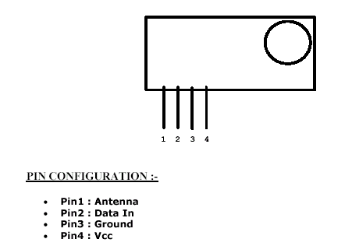

KEY FEATURES

Frequency: 433.92 MHz
- 5 – 12V Single Supply Operational
- OOK / ASK Data Format
- Up to 9.6 kbps data rate
- 4 Pin compact size module
- + 5 dbm out put power ( 12V, Vcc )
- SAW based architect
- Vertical / Horizontal mount
- Directly connect to microcontoller
- Low Power Consumption suitable for battery operated devices
- Direct plug and use
- No external components required
- High performance SAW based Architecture with a maximum range of100 feet at 4800 bps data rate
- Interface directly to Encoders and Microcontrollers with ease
- Can be directly in your PCB
- Right Angle Pin ( Flat Out ) is the standard in these modules
- Can be used with Fixed Code and Rolling Code Encoders or direct with Microcontrollers.

The TWS-434 and RWS-434 are extremely small, and are excellent for applications requiring short-range RF remote controls. The transmitter module is only 1/3 the size of a standard postage stamp, and can easily be placed inside a small plastic enclosure.
TWS-434: The transmitter output is up to 8mW at 433.92MHz with a range of approximately 400 foot (open area) outdoors. Indoors, the range is approximately 200 foot, and will go through most walls.....
TWS-434A
The TWS-434 transmitter accepts both linear and digital inputs, can operate from 1.5 to 12 Volts-DC, and makes building a miniature hand-held RF transmitter very easy. The TWS-434 is approximately the size of a standard postage stamp.
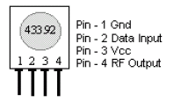
TWS-434 Pin Diagram

SM RX – 433 RECEIVER MODULE

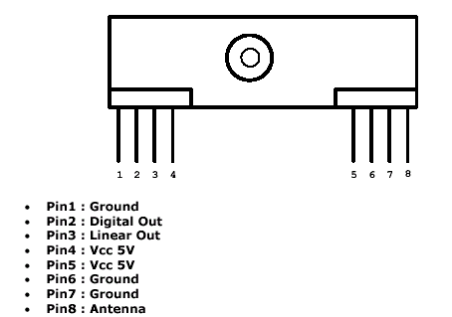

FEATURES

- Miniature Size
- Wide Operating Range
- Low Power Consumption
- Improved Data Transmission
- No Alignment Required
- No External Components PIN Configuration and Size
- Wide Range of Application
- Analogue and Digital Output

RWS-434: The receiver also operates at 433.92MHz, and has a sensitivity of 3uV. The RWS-434 receiver operates from 4.5 to 5.5 volts-DC, and has both linear and digital outputs.
Click on picture for larger image
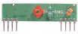
RWS-434 Receiver
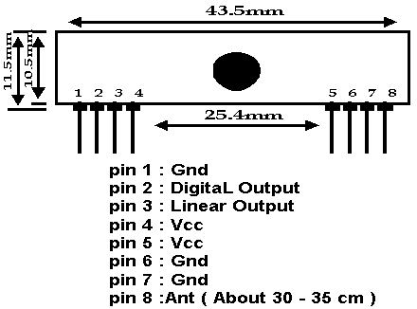
RWS-434 Pin Diagram
Note: For maximum range, the recommended antenna should be approximately 35cm long. To convert from centimeters to inches -- multiply by 0.3937. For 35cm, the length in inches will be approximately 35cm x 0.3937 = 13.7795 inches long. We tested these modules using a 14", solid, 24 gauge hobby type wire, and reached a range of over 400 foot. Your results may vary depending on your surroundings.

RF Transmitter

Antenna Description

The TX4915 is a low power ASK transmitter IC intended for applications in the North American and European VHF/UHF and ISM bands. The integrated voltage-controlled oscillator (VCO), phase/frequency detector, prescaler, and reference oscillator require only the addition of an external crystal to provide a complete phase-locked loop (PLL). In addition to the standard power-down mode, the chip also includes an automatic lock-detect feature that disables the transmitter output when the PLL is out-of-lock.

Features

- Output frequency range: 300 – 960 MHz;
- Supply voltage range: 2.2 – 3.6 V;
- Low current consumption with power down capability;
- On-chip VCO with integrated PLL (÷ 64/128) dual modulus prescaler;
- Out-of-lock inhibit circuit;
- SSOP-16 package (0.64 mm pitch).

Applications

Wireless mouse
Car alarm and home security systems
Remote control systems

Block Diagram

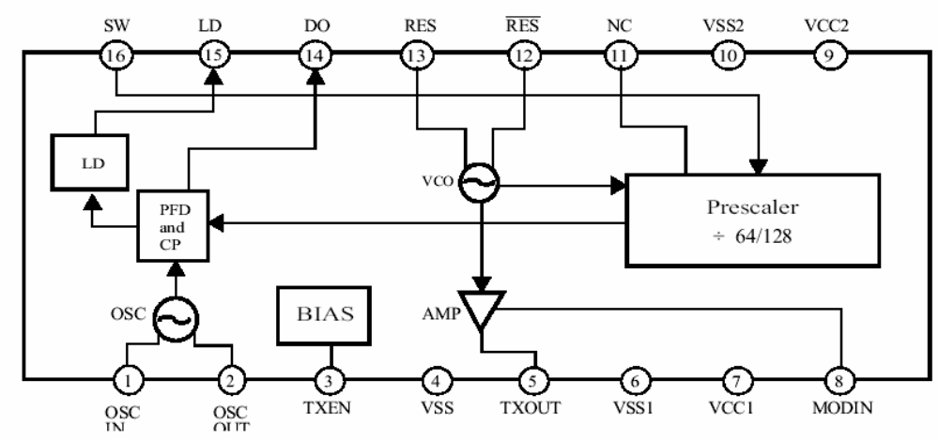

RF Receiver (RX3400 Low Power ASK Receiver IC)

Description

The RX3400 is a low power ASK receiver IC which is fully compatible with the Mitel KESRX01 IC and is suitable for use in a variety of low power radio applications including remote keyless entry. The RX3400 is based on a single-conversion, super-heterodyne receiver architecture and incorporates an entire phase-locked loop (PLL) for precise local oscillator generation.

Features
- Extremely low power operation;
- Low external part count;
- Receiver input frequency: 290 – 460 MHz;
- On-chip VCO with integrated PLL using crystal oscillator reference;
- PLL power down feature;
- Integrated IF and data filters;
- SSOP-24 package (0.64 mm pitch).

Applications

Wireless mouse
Video sender remote controller
Car alarm and home security systems

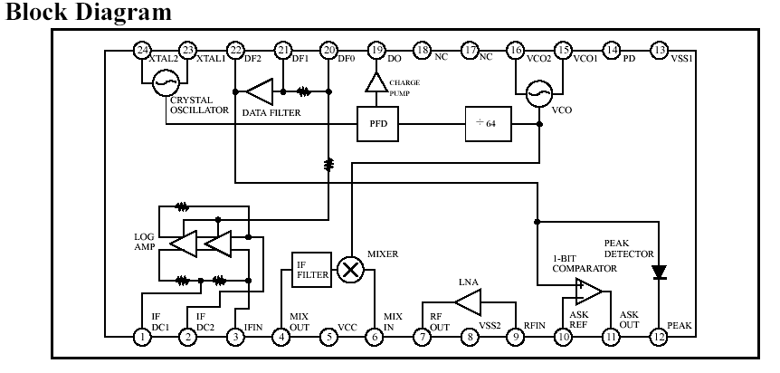

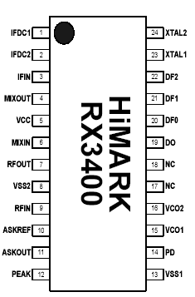
Pin Descriptions
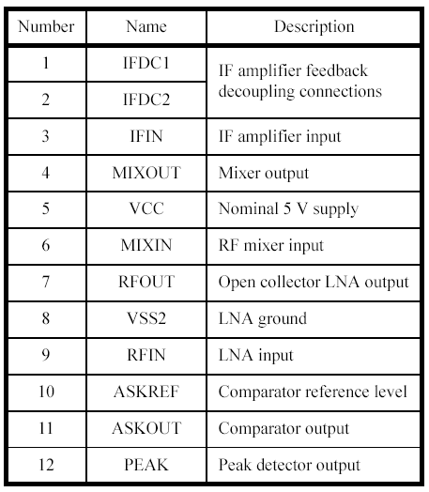
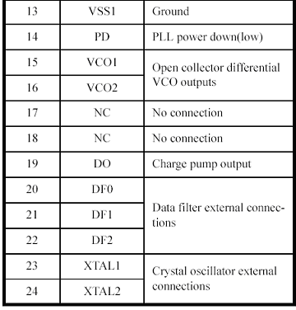
- Sensitivity is defined as the minimum average signal level measured at the input which is necessary to achieve a bit error rate of 0.01 when the input signal is a return-to-zero (RZ) pulse with an average duty cycle of 50%. The RF input is assumed to be matched to 50 ohms.

- Signal handling is defined as the maximum input signal capable of being successfully demodulated. It is assumed that the input signal is ASK modulated with a minimum extinction ratio of 40 dB. The RF input is assumed to be matched to 50 ohms.

- Adjacent channel rejection is defined for an interfering tone áACR [dB] above the receiving threshold and 10 MHz offset from the carrier giving a 3 dB reduction in sensitivity.

- The IFDC1/IFDC2 can be used as a Received Signal Strength Indicator (RSSI), and the relationship between sensed dc level and input power need to fine tune.

